Connecting Your Computer to the FasTrak2™ Portable

Introduction

The following describes how to connect a monitoring computer to the FasTrak2™ Board through the computer's ethernet port. It is assumed that you are installing this on a computer of your own. If you purchased a computer from Visi-Trak Worldwide these steps will have already been done.

Table of Contents

- Determining the TCP/IP Address of the FasTrak2™ Board
- Setting up the Ethernet Port on the Computer
- Connecting the Computer to the FasTrak2™ Board

Determining the TCP/IP Address of the FasTrak2™ Board
The original ip address, the address of the board when it is shipped from Visi-Trak Worldwide, is marked on a label on the main FasTrak2™board. It is shown here with a red oval.
Also shown here are the locations of switch SW8 and the two seven segment leds located on this board.
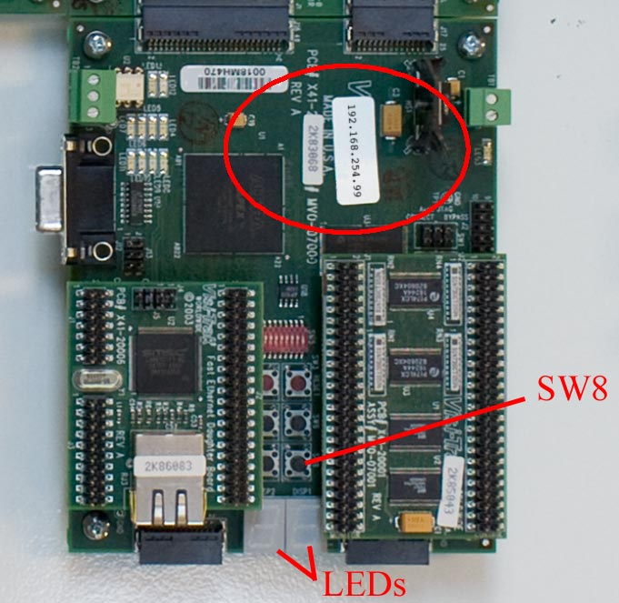

Pressing SW8 causes the ip address to scroll across the leds.
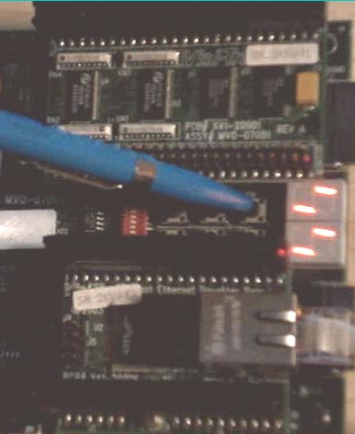

The following pictures show the sequence of changes to the leds as they would appear
if you tilted your head to the right, which makes it easier to decipher the address as it scrolls.
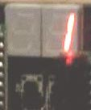
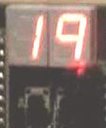
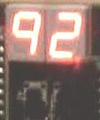
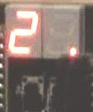

1 19 192 192.
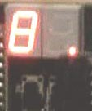
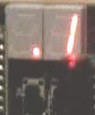
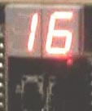
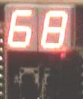

192.1 192.16 192.168 192.168.
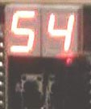
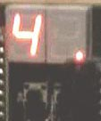
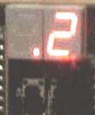
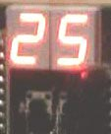

192.168.2 192.168.25 192.168.254 192.168.254.
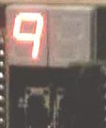
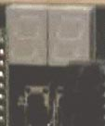
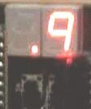
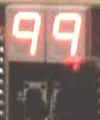

192.168.254.9 192.168.254.99

Setting Up the Ethernet Port on the Computer
The following is a description of how to connect a FasTrak2™ board to a monitoring computer.
If your computer is close enough to the FasTrak2™ board, we recommend that you use a cat5 crossover cable that goes directly from the FasTrak2™ board to the ethernet port on the computer.
In any case, connect the ethernet ports between the FasTrak2™ board and the computer and power up both.
On the computer, open the Network Connections dialog.

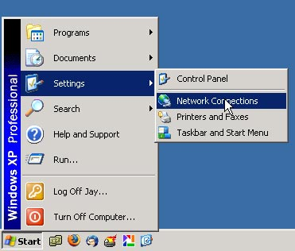

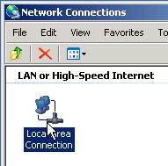
Double click on the icon for the ethernet port that you are going to connect to.

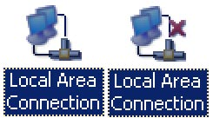
If you have more than one port and don't know which you are going to use, try plugging and unplugging the ethernet cable from the port you are going to use. When you unplug the cable, an 'X' will appear in the symbol for the port that you were connected to on the computer.

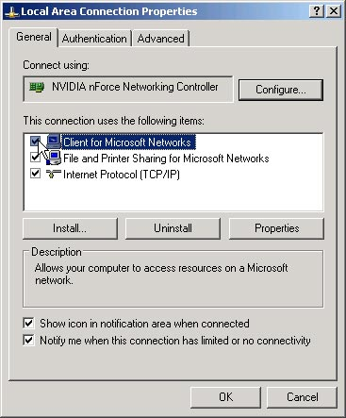

When you double click on the icon for the ethernet port the properties dialog for that port will appear.

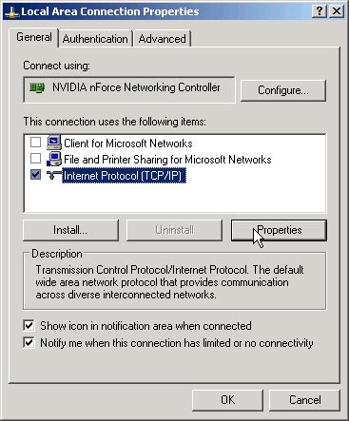
If you are connecting directly to the FasTrak2™ board uncheck all but the "Internet Protocol (TCP/IP)".

Click once on the "Internet Protocol (TCP/IP)"
to highlight it and then press the "Properties" button.

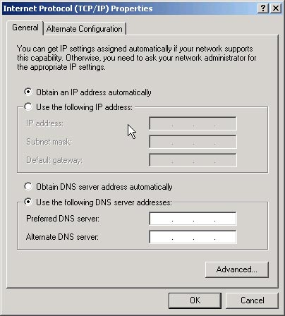

The Internet Protocol Properties dialog will appear. It will probably be set to obtain an IP address automatically.

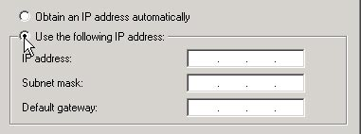
Click the "Use the Following Ip Address"
radio button.

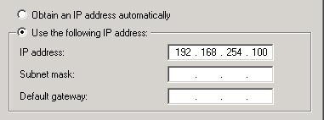
Enter an IP address for the computer.
The first three numbers of this address, "192.168.254" in this example, must be the same as those of the FasTrak2 board.
The last number must be different.
In this example the FasTrak2 board has an address of 192.168.254.99.
For the computer the last number can be any number except 99 (in the range 1 to 255). I have chosen to use 192.168.254.100 for the address.

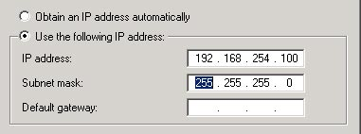
Pressing the "Tab" key will move the cursor to the "Subnet Mask" field. Normally this will be filled in automatically.
If not just enter 255.255.255.0 for the subnet mask.

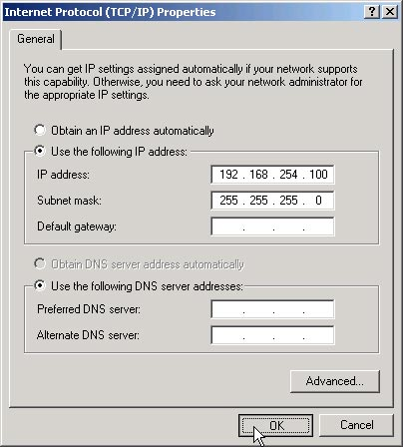

Press the "OK" button to close the Internet Protocol Properties dialog.

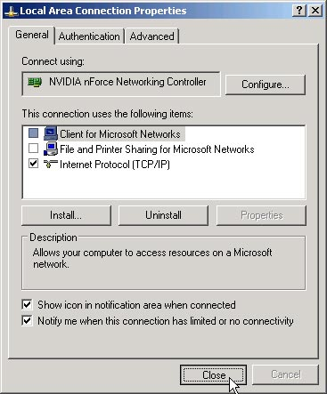

Press the "Close" button to close the Local Area Connection Properties.

Getting the Program to Talk to the FasTrak2 Board

Make sure the ethernet cable connects the computer to the FT2 Portable and that the FT2 Portable is turned on.
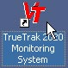
Start the True-Trak program on the computer.

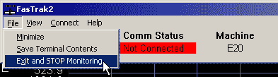
If the "FasTrak2" program is running, pull down the "File" menu and choose "Exit and STOP Monitoring" to shut the program down.
You may have to do this twice.

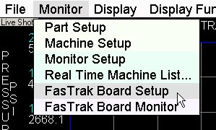
Pull down the "Monitor" menu and choose "FasTrak Board Setup".

When the FasTrak Board Setup dialog appears, check the "Address" of the FasTrak2 board, pointed to on the picture below, and make sure it is the same as the actual address of the FasTrak2 board that you are trying to connect to.
Press the "Save Changes" button at the bottom of the dialog and then close the dialog.
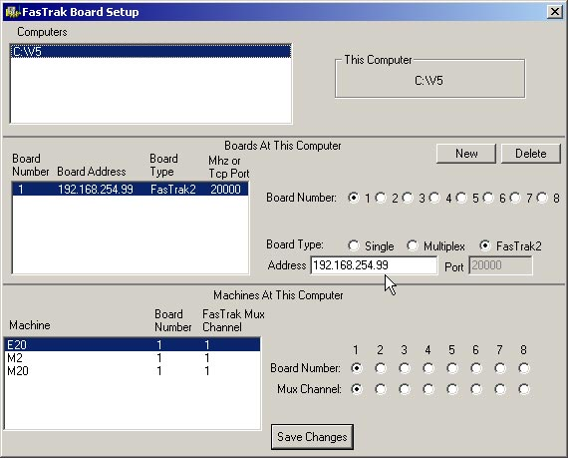

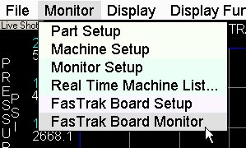
Pull down the "Monitor" menu and choose "FasTrak Board Monitor".

The FasTrak Board Monitor program will appear and should immediately connect with the FasTrak2 Board. This is indicated by the word "Connected" under the "Comm Status".
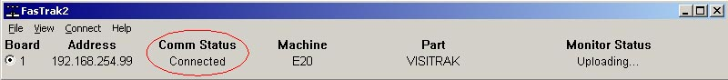

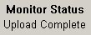
If this is the first time you have connected to this FasTrak2 board you will see the "Monitor Status" display "Uploading..." for a second or two and then it will display "Upload Complete".

